**Managing Log Files Lab**

## Accessing the AWS Management Console

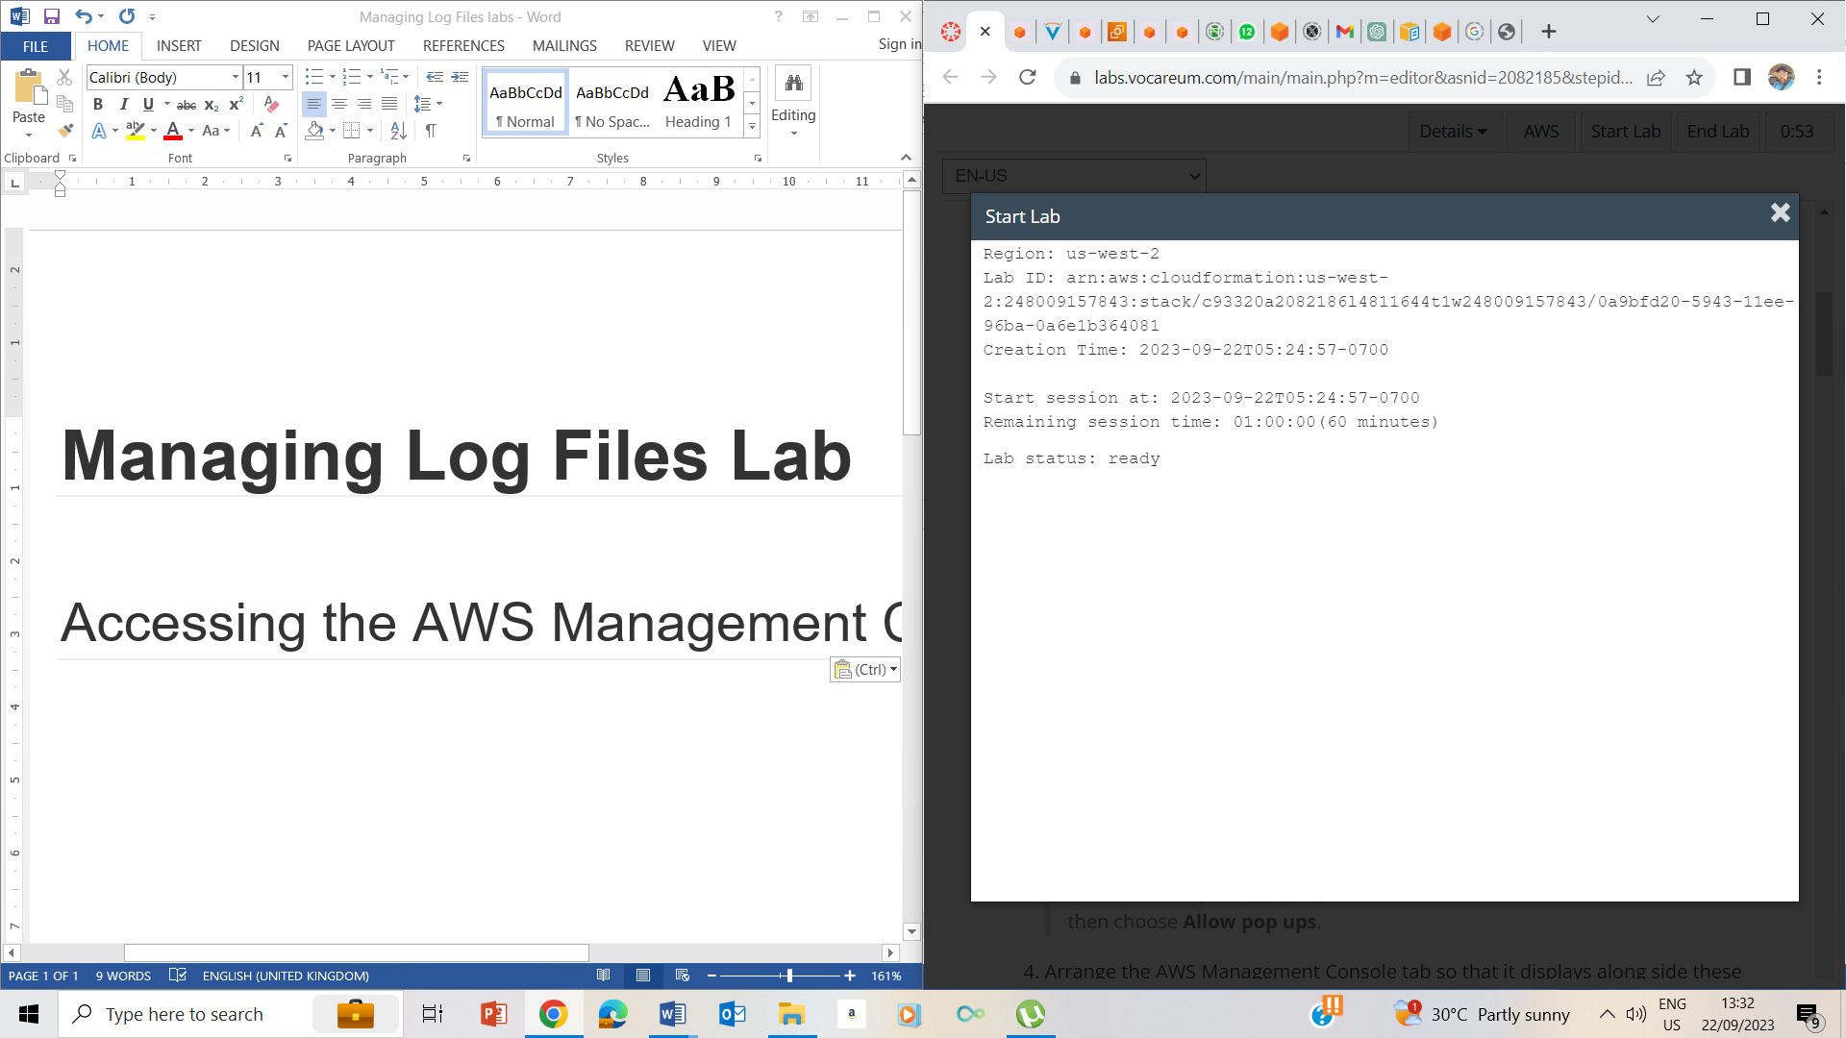

* 1. Start Lab ->ready

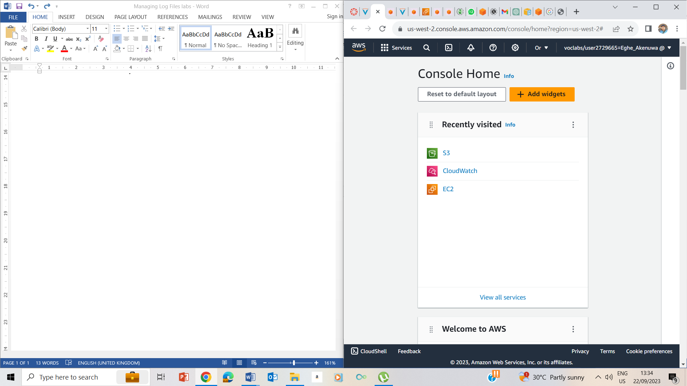

3. Clicked on the AWS button to take me to the AWS management console.

## Task 1: Use SSH to connect to an Amazon Linux EC2 instance

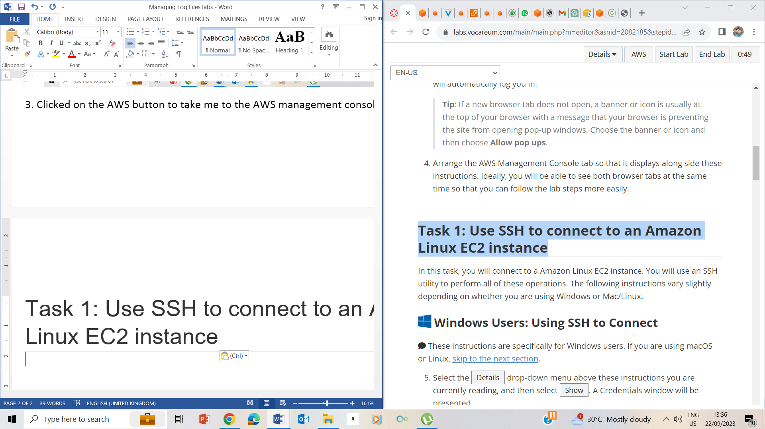

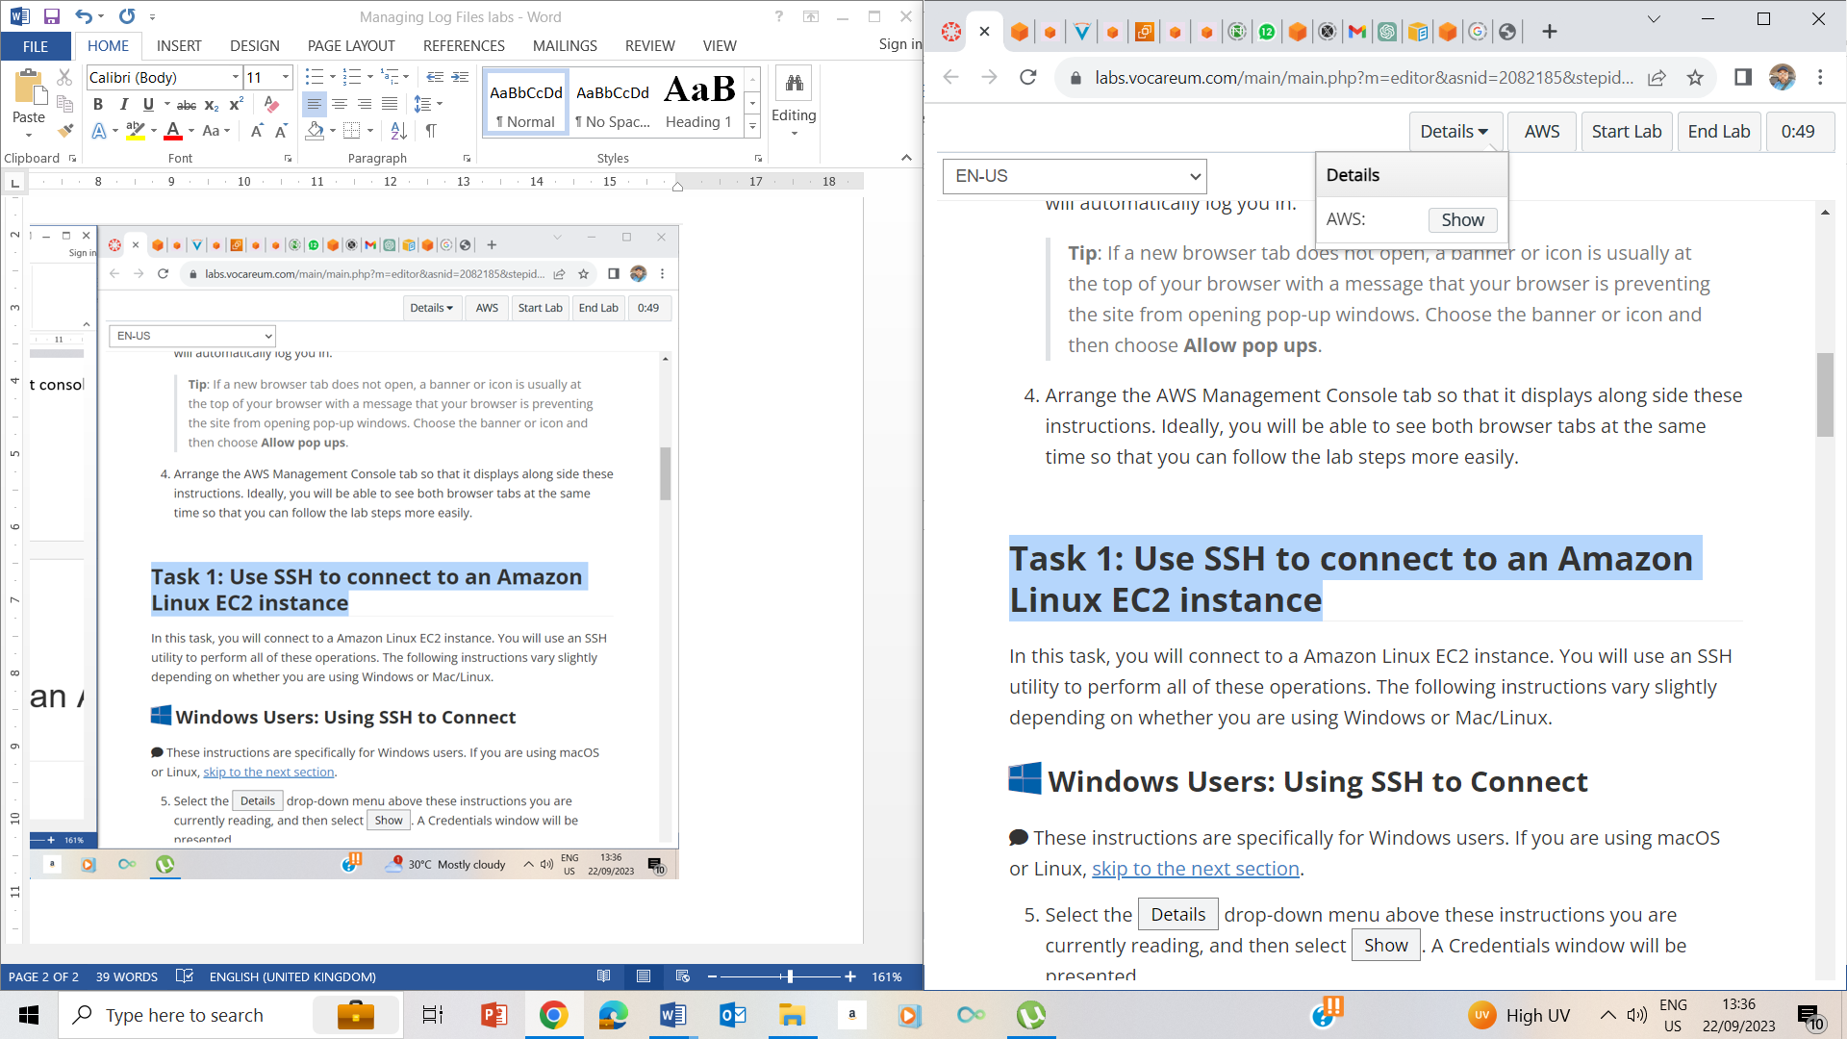

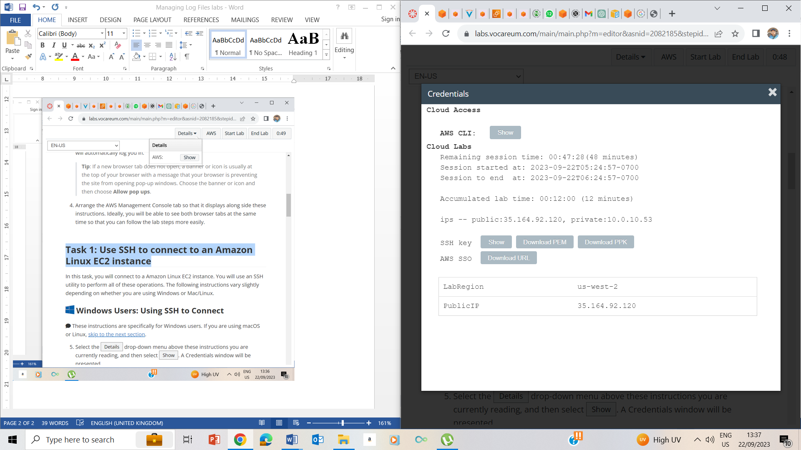

5. Clilcked on Details drop down box, then I clicked on show button, noted the Public ip address as 35.164.92.120, and also downloaded the PPK file.

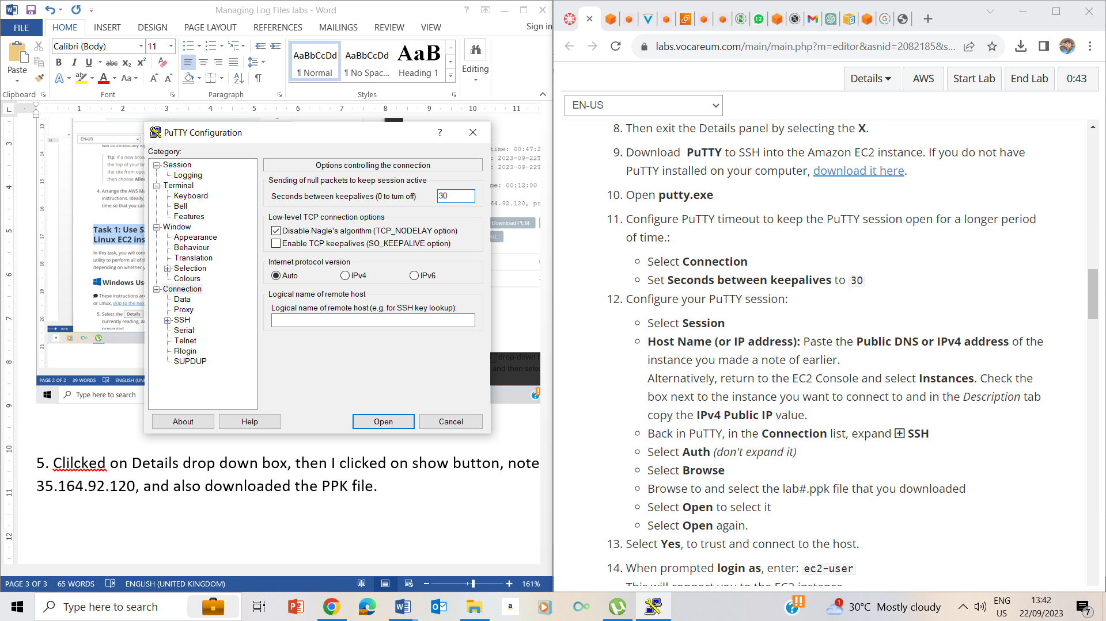

10-11. I opened putty.exe and selected connection and set the time between keepalives to 30

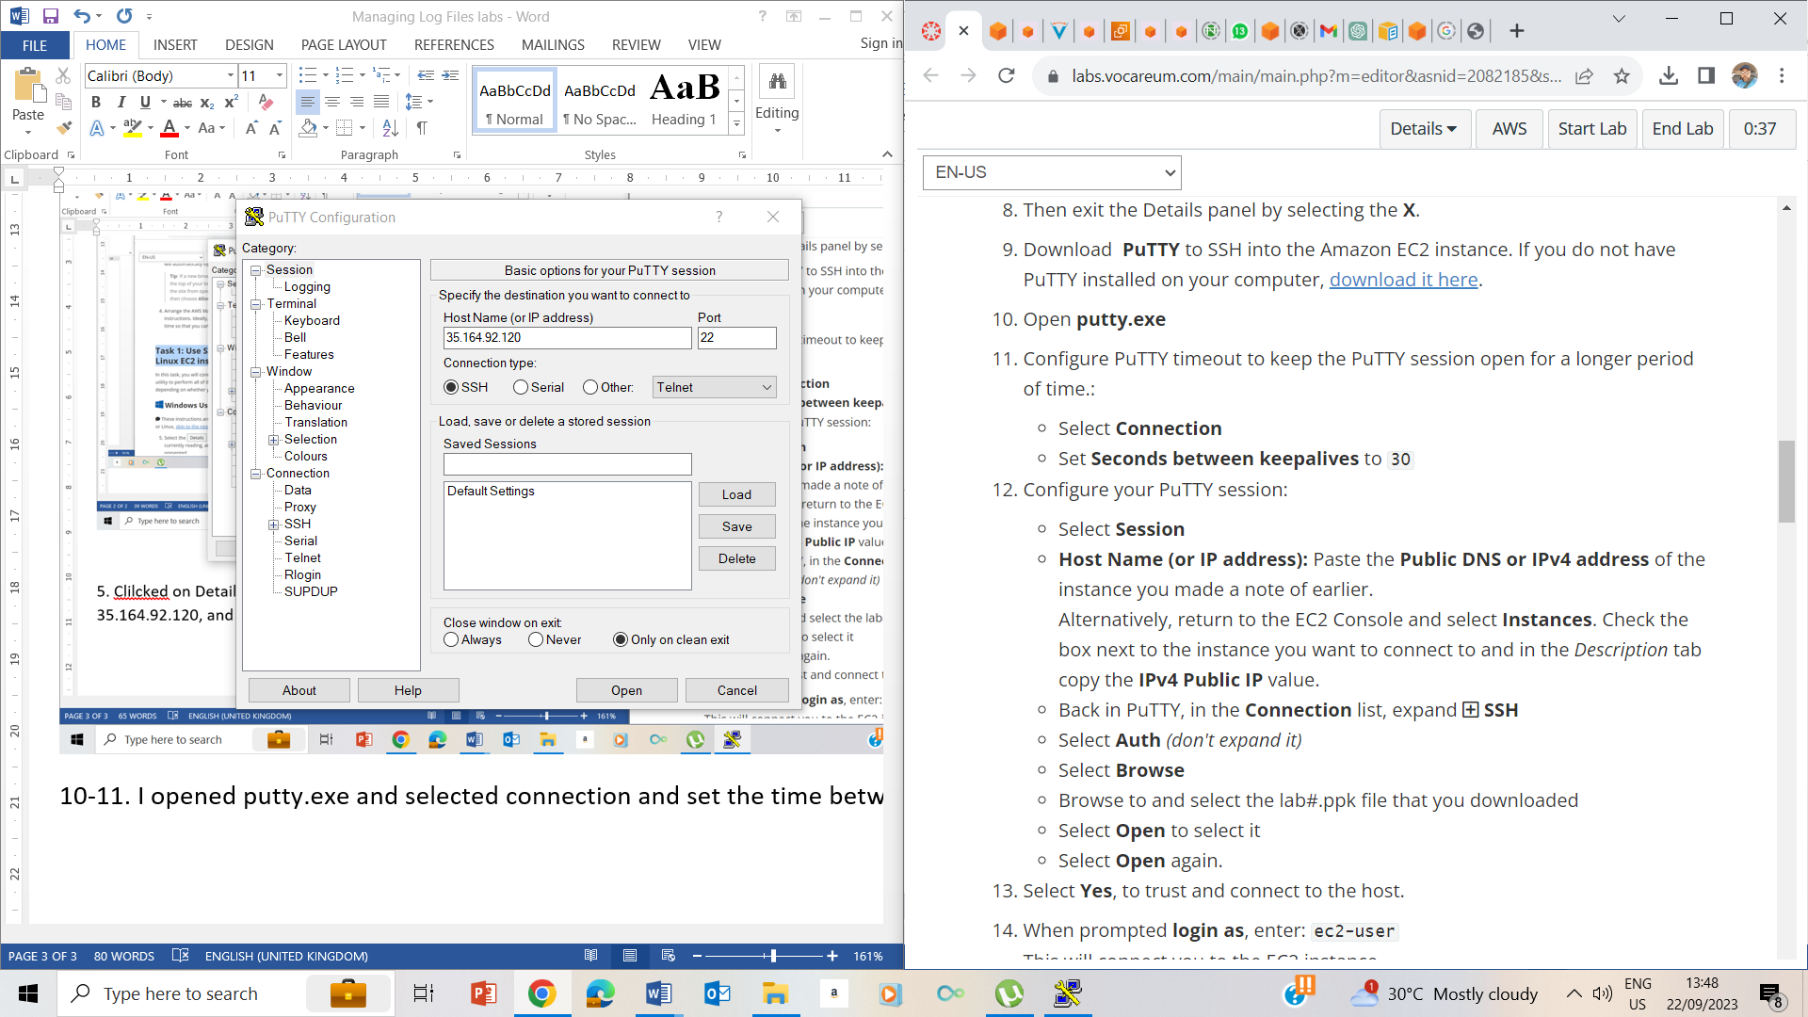

Selected session and on the host name or ip address, inputted the public ip address

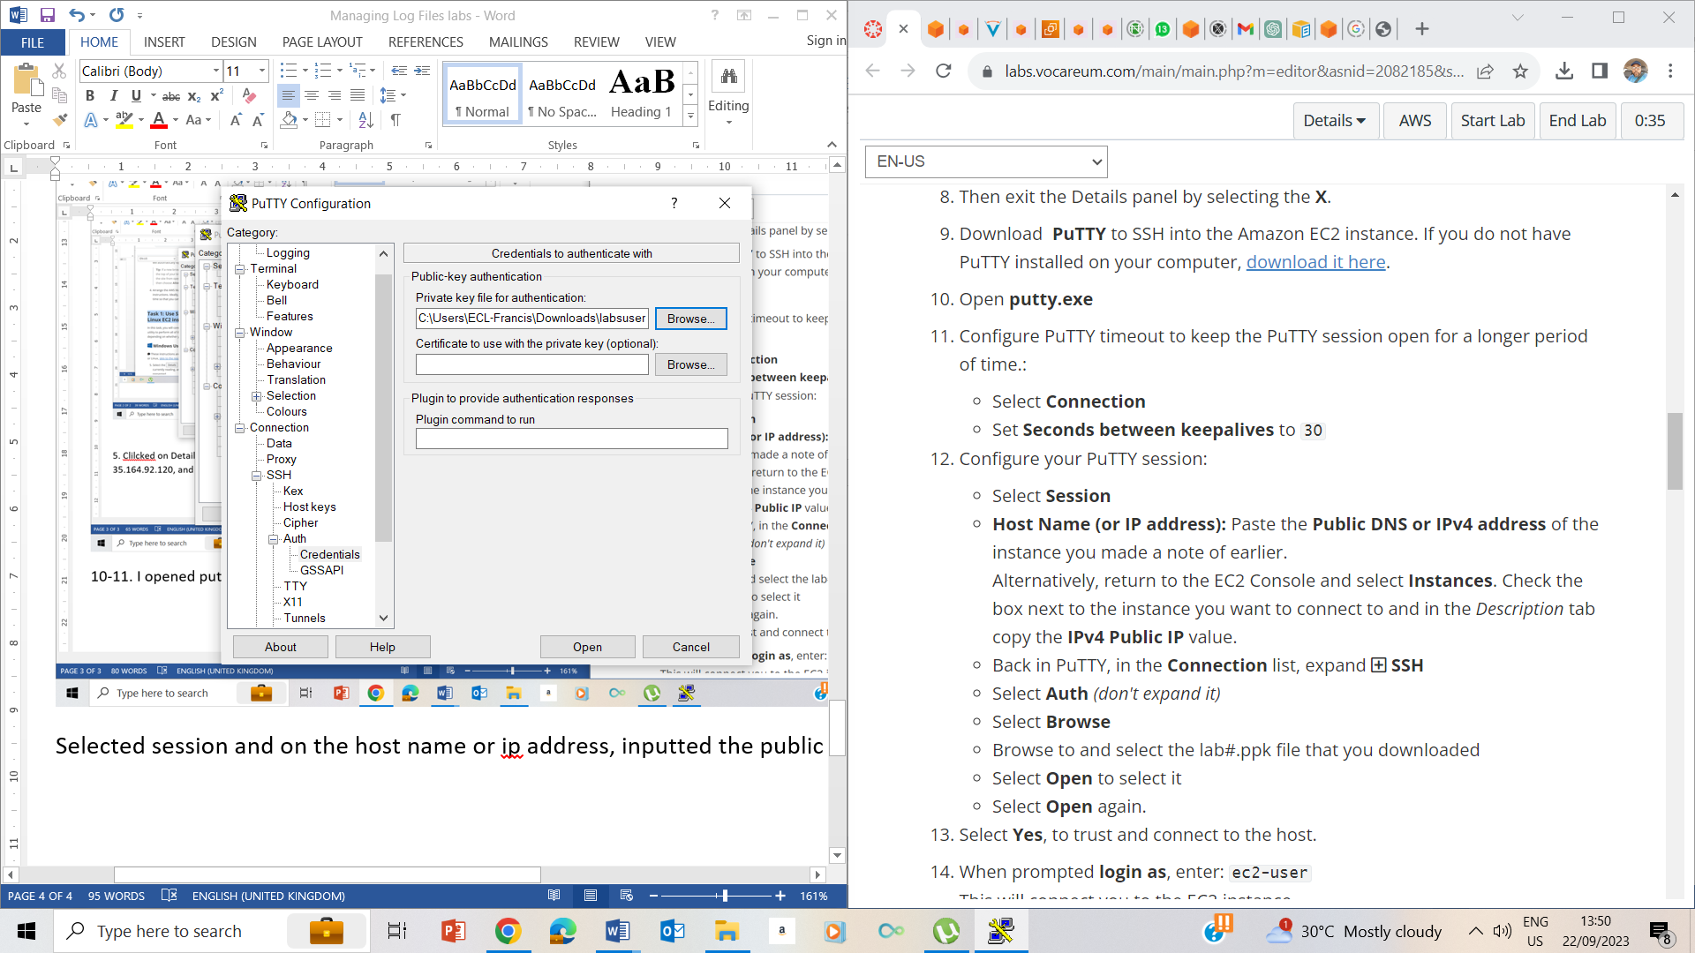

12. configured the putty session according to the instructions

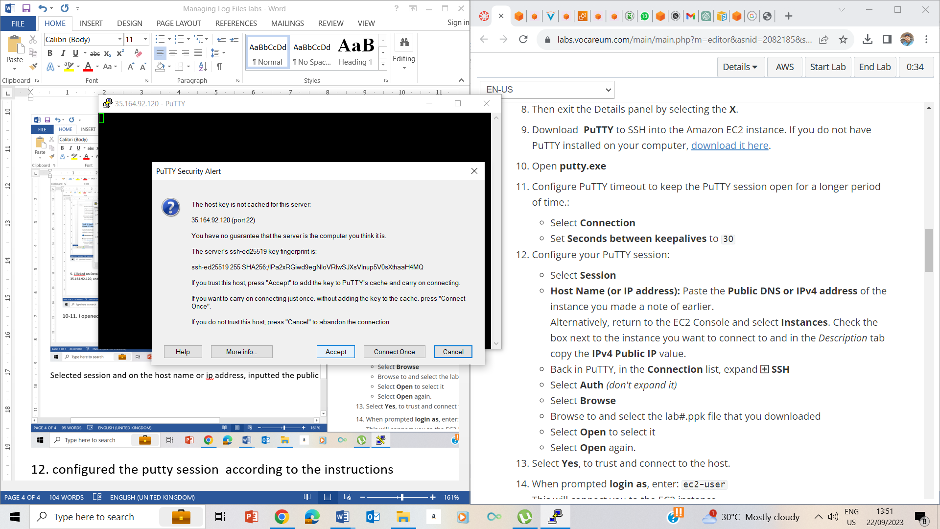

13. selected Accept to trust and connect to the host

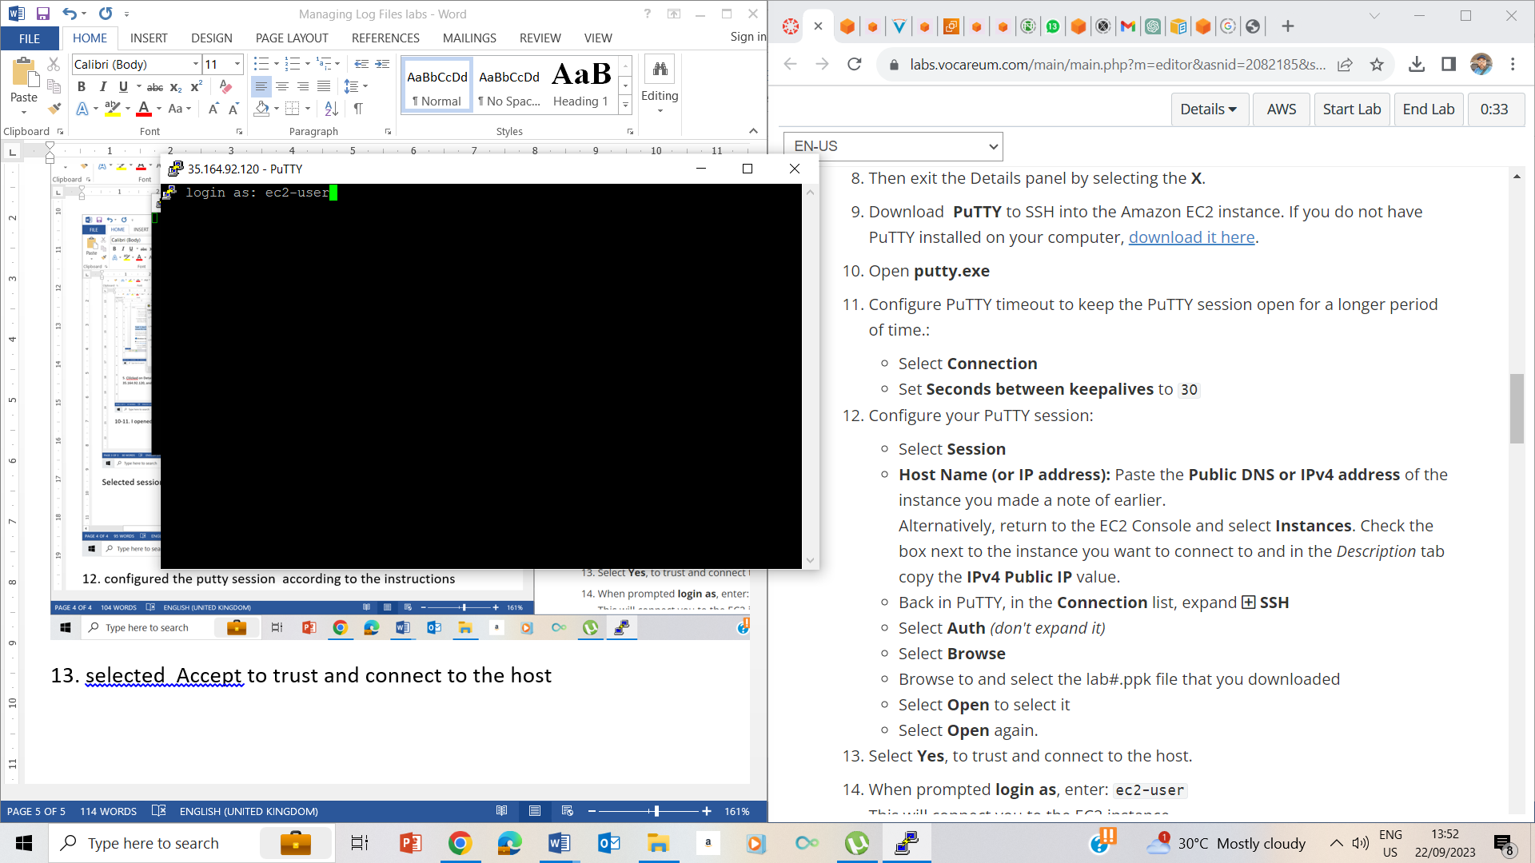

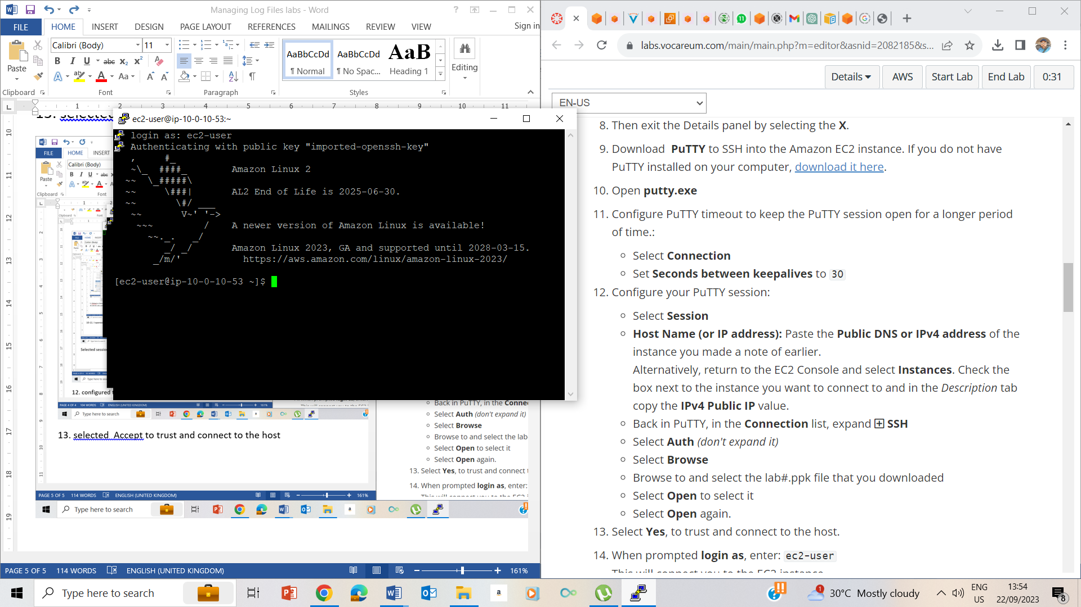

13. Logged in as ec2-user

## Task 2: Review secure log files

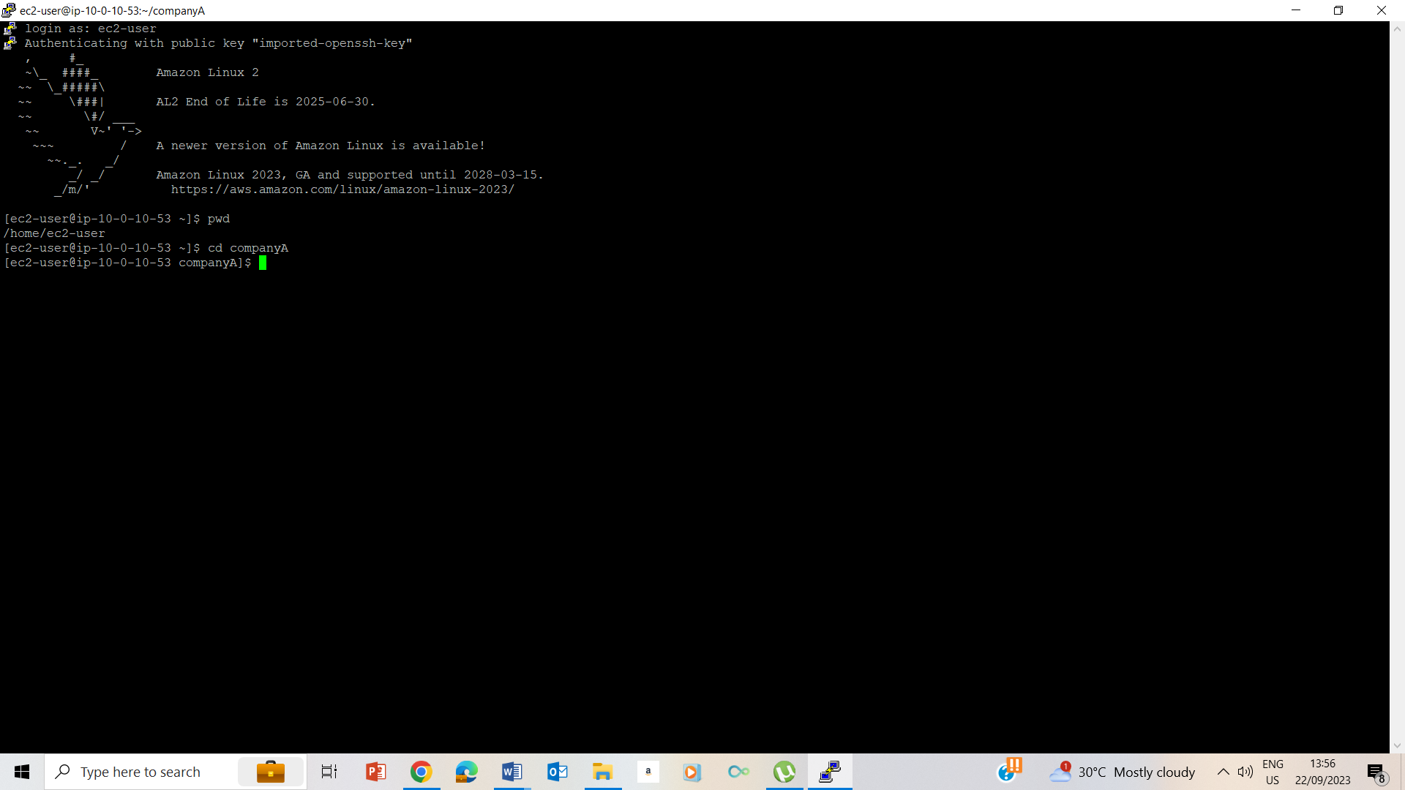

24. used pwd and cd companyA to go to comapanyA folder

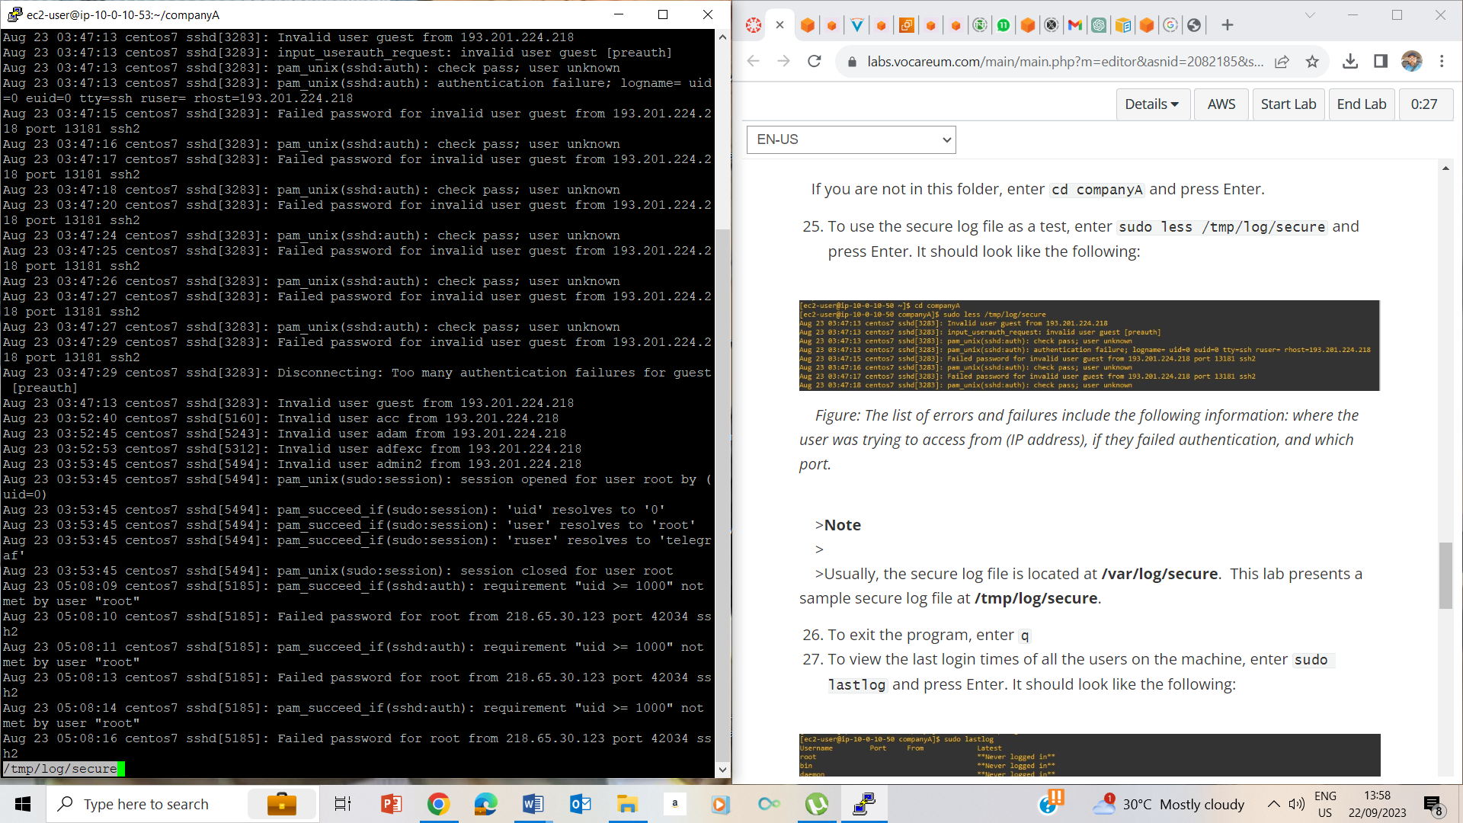

25. secure log file

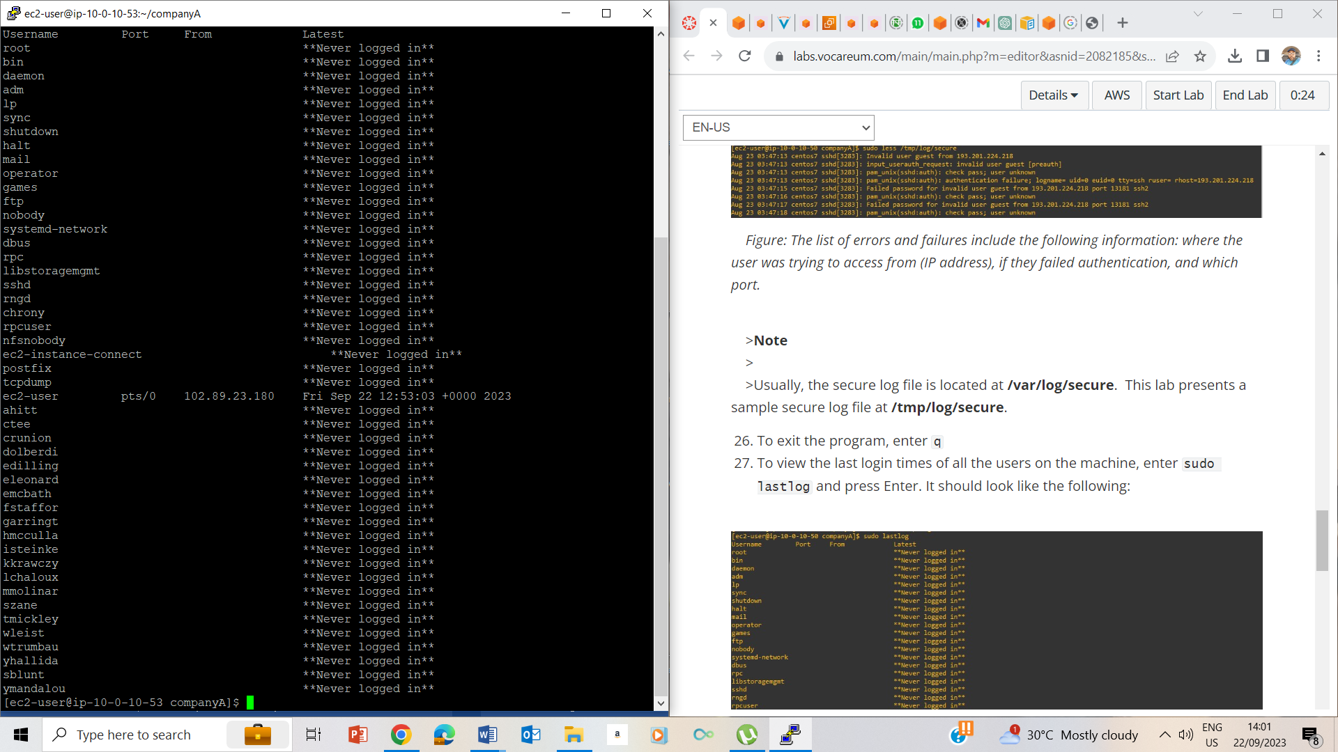

27. viewed last log in using sudo lastlog

Additional Challenge- we can use this for accountability purpose helping us know which user assed which item on the system and when.

## Lab Complete

